**Oracle Database and RMAN Configuration**

*Prepared By.*

**Badar Din Zounr**

*Team Lead Software*

**Contents**

1. **Database Creation using DBCA (Database Configuration Assistant)**
2. **Schema Creation with tablespace and DBF (Database) file.**
3. **RMAN Backup Configuration**
4. **Disaster Recovery On Finger Tips**

**Copyrights**

**Copyright @2017 to Software Channel (Pvt) Ltd.**

All rights reserved. No part of this publication may be reproduced, distributed, or transmitted in any form or by any means, including photocopying or other electronic or mechanical methods, without the prior written permission of the company, except when using for deployment purpose on client side but required permission from Software Channel.

1. **Database Creation using DBCA (Database Configuration Assistant)**

Follow these steps to create New Database using DBCA utility in Oracle .

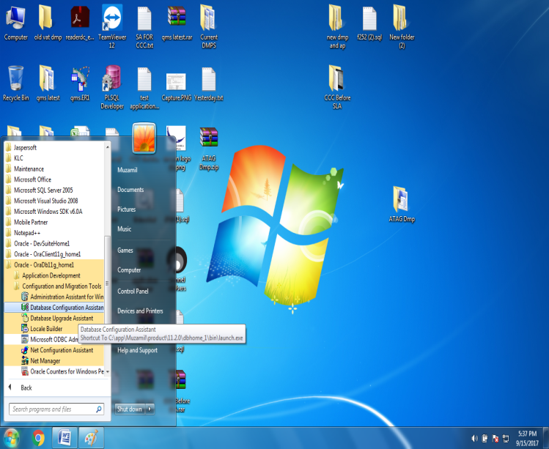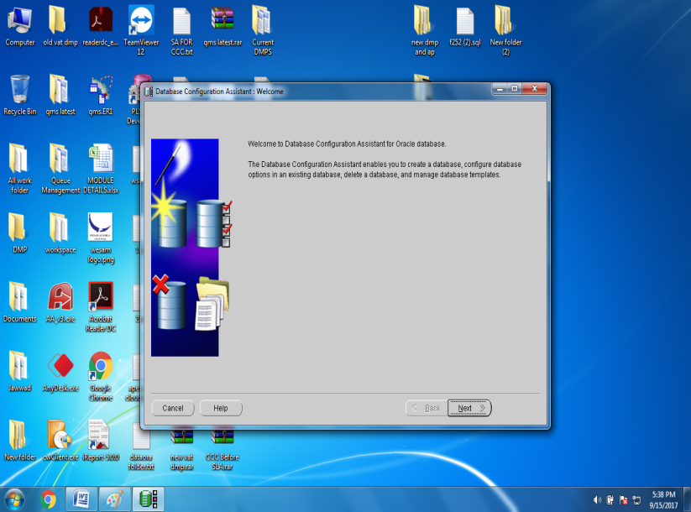

Create New Database

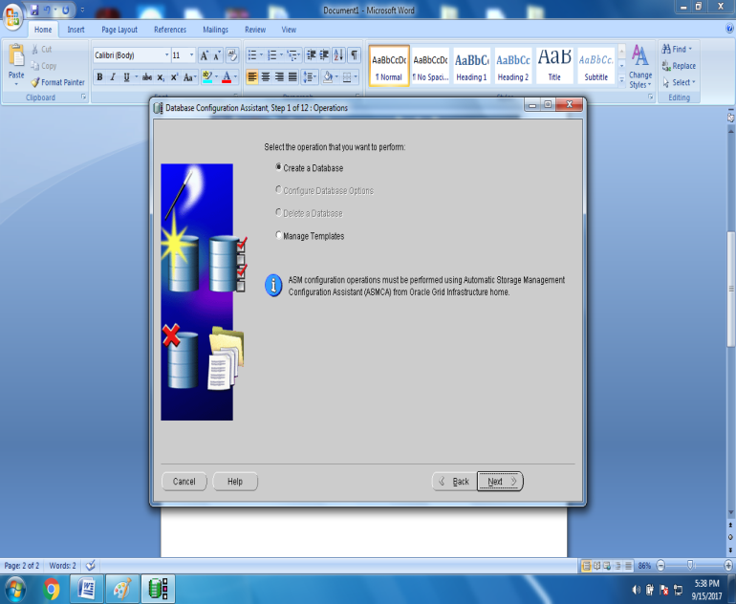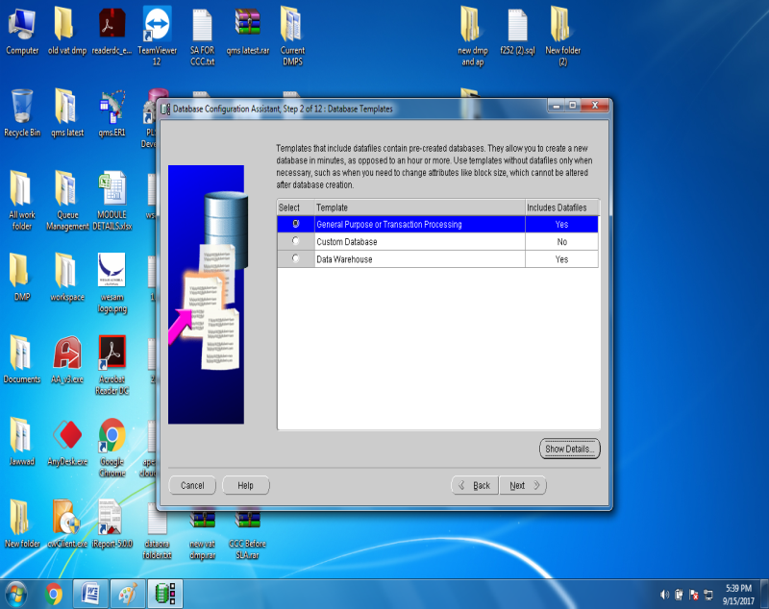

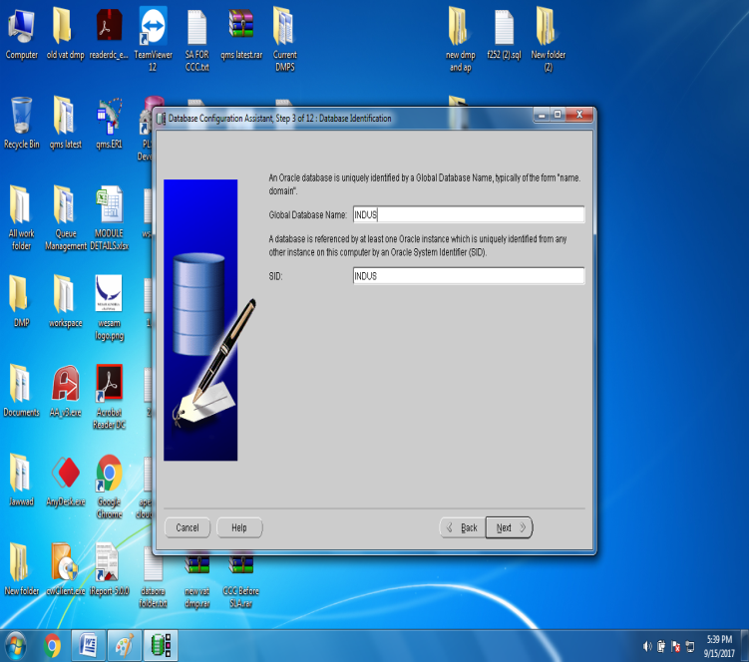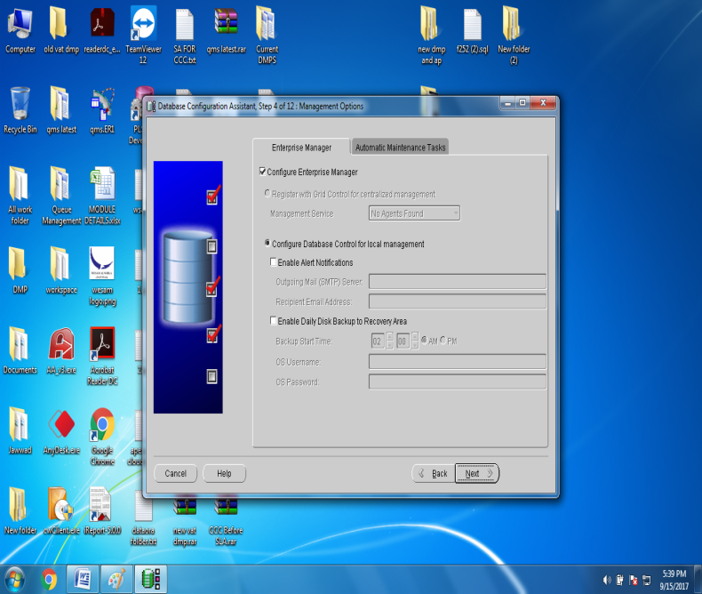

**Enter Database Name and Click NEXT Click NEXT**

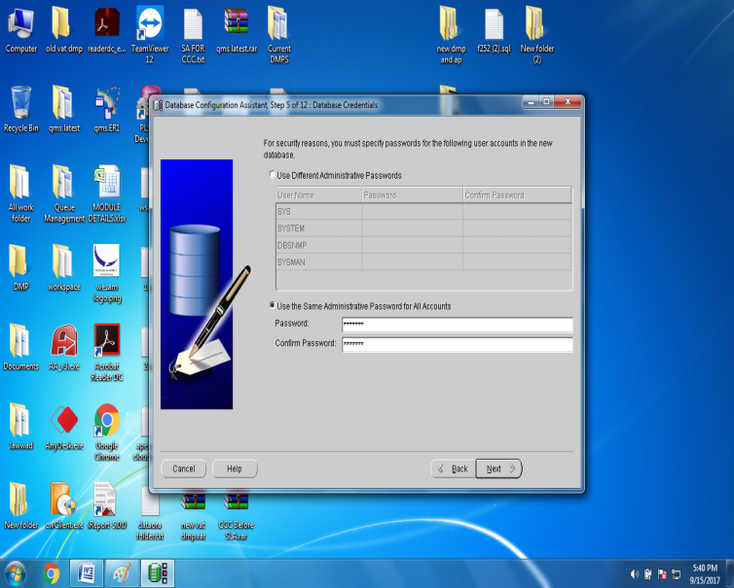 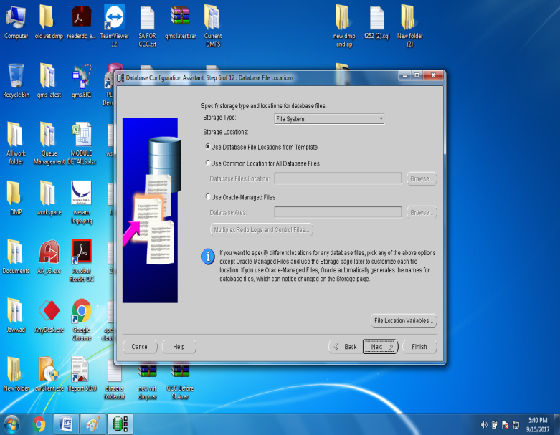

**Click NEXT Click NEXT**

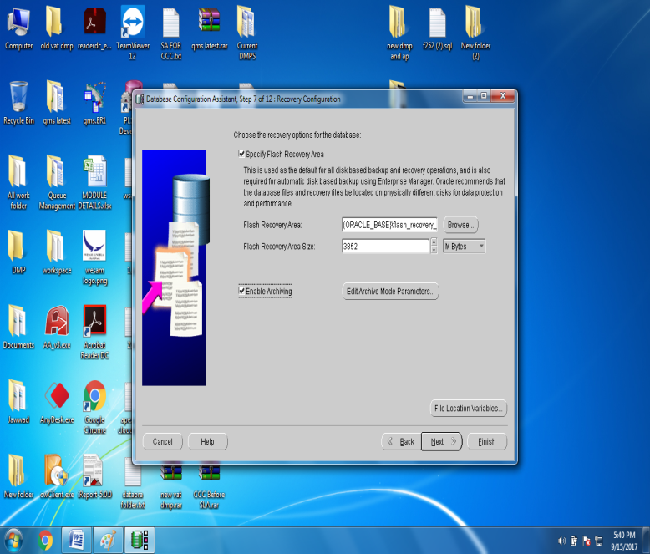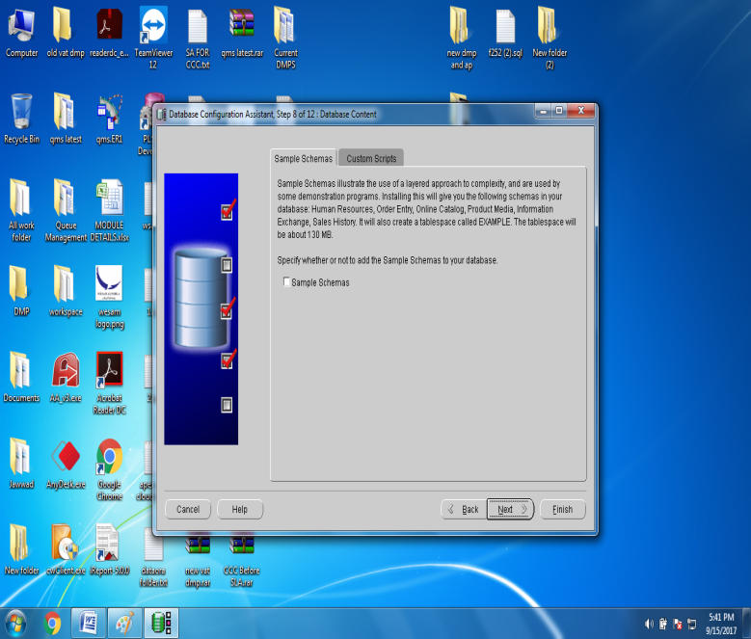

Check BOX “YES” to **Enable Archiving** and click NEXT **Click NEXT**

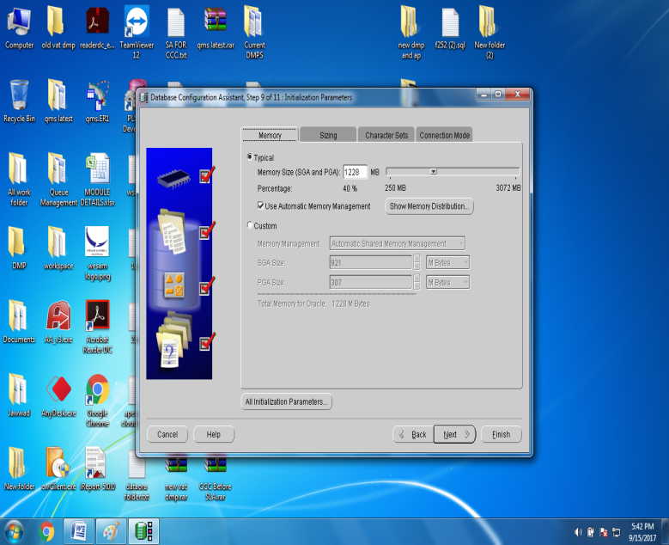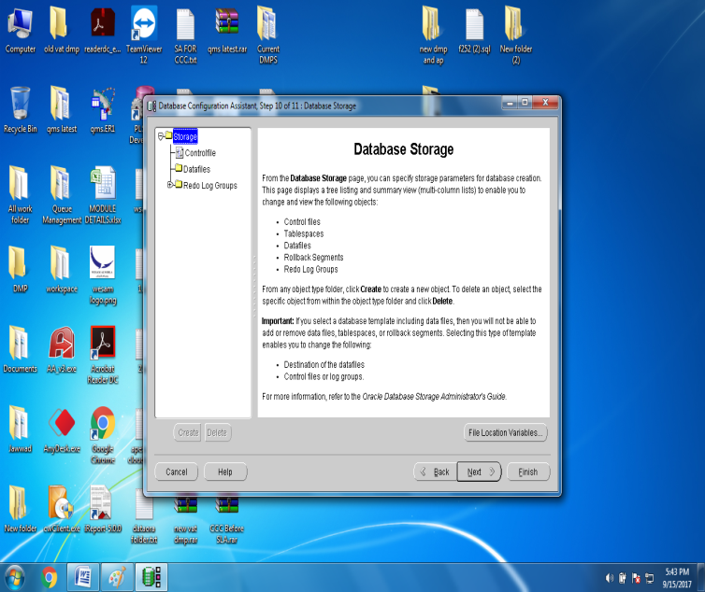

**Click NEXT**  **Click NEXT**

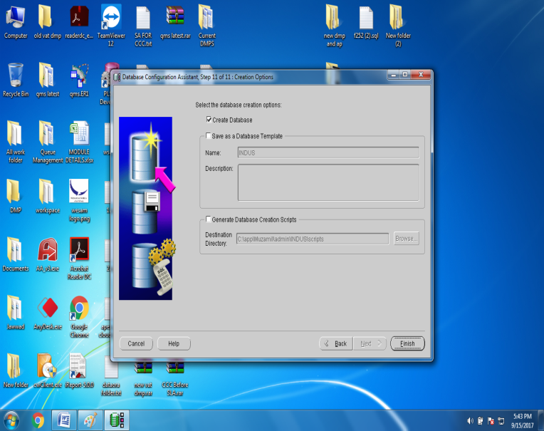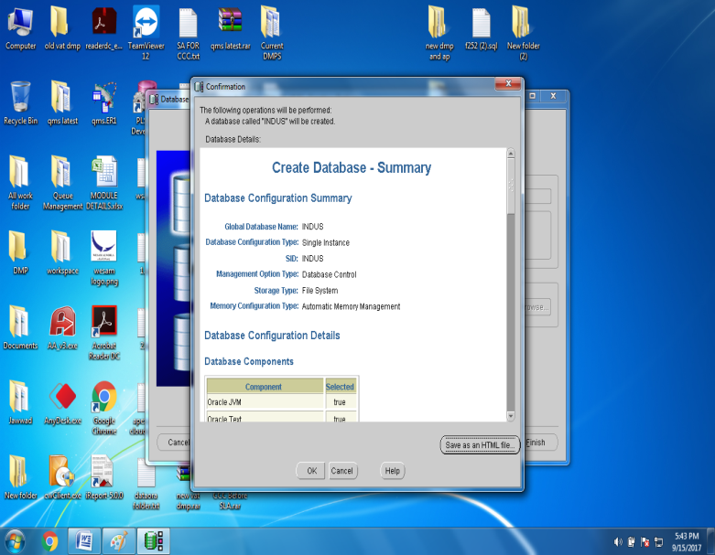

Click OK

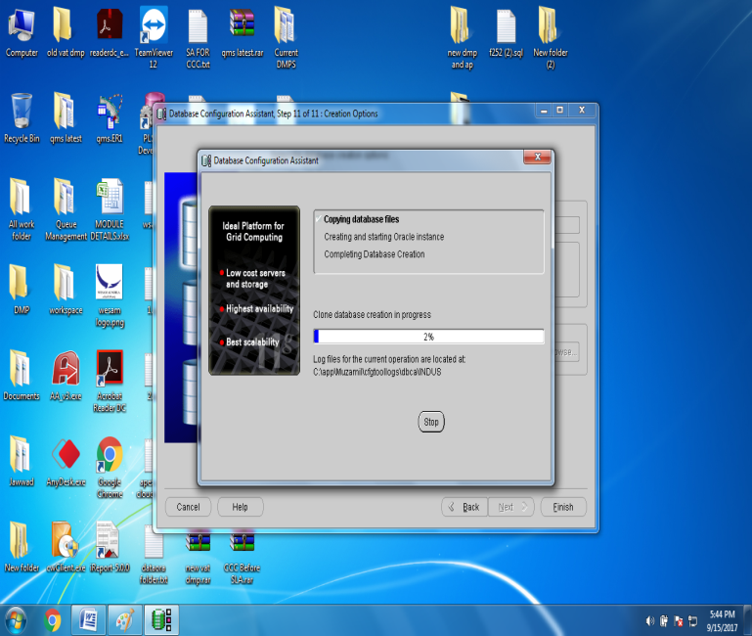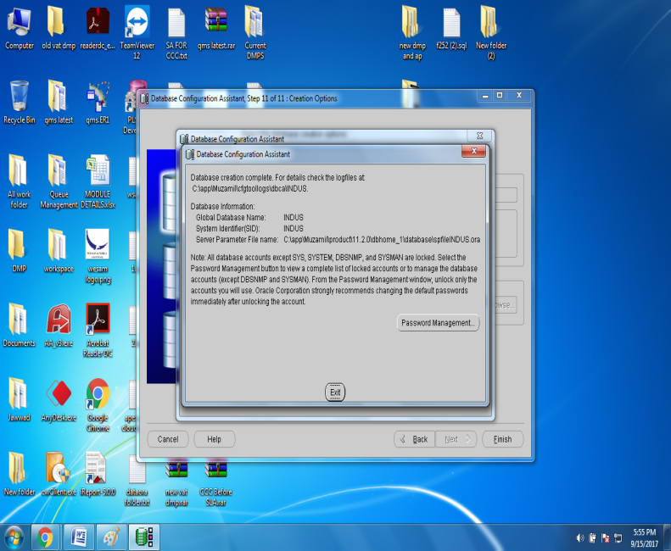

**Wait until you will be asked DB System Schemas Password Click OK**

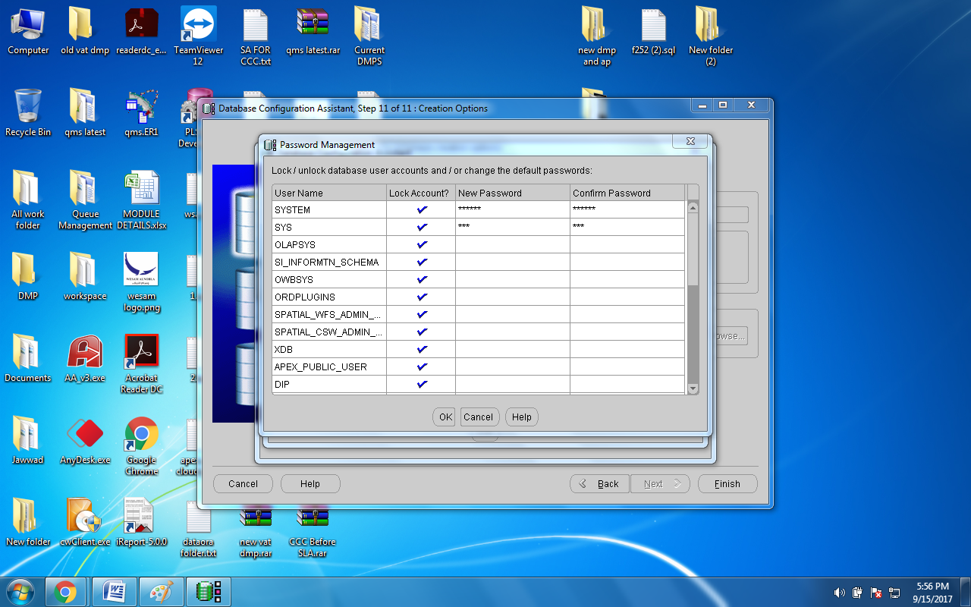

Enter Schema Passwords (SYSTEM,SYS)

Test Database Server Working with TNS Listener

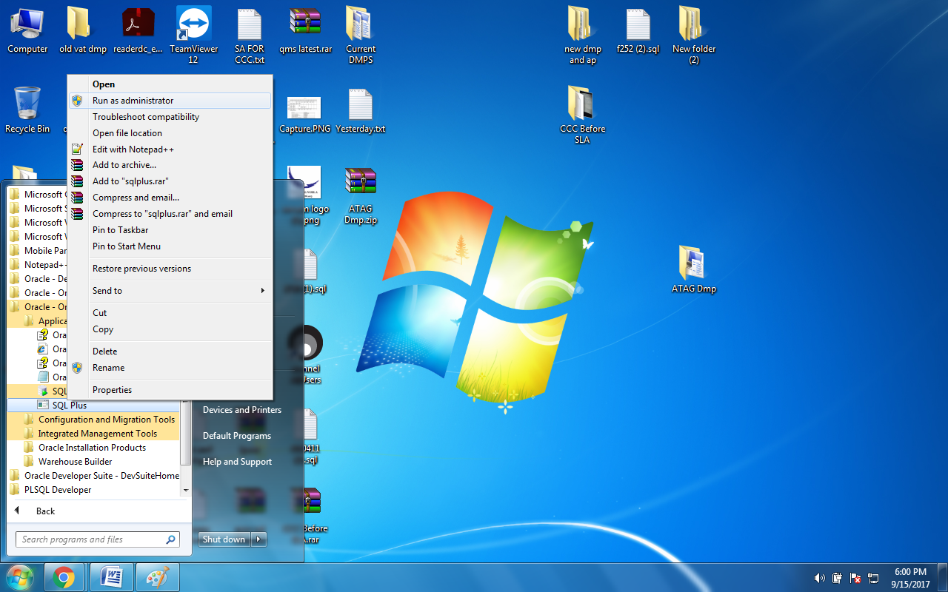

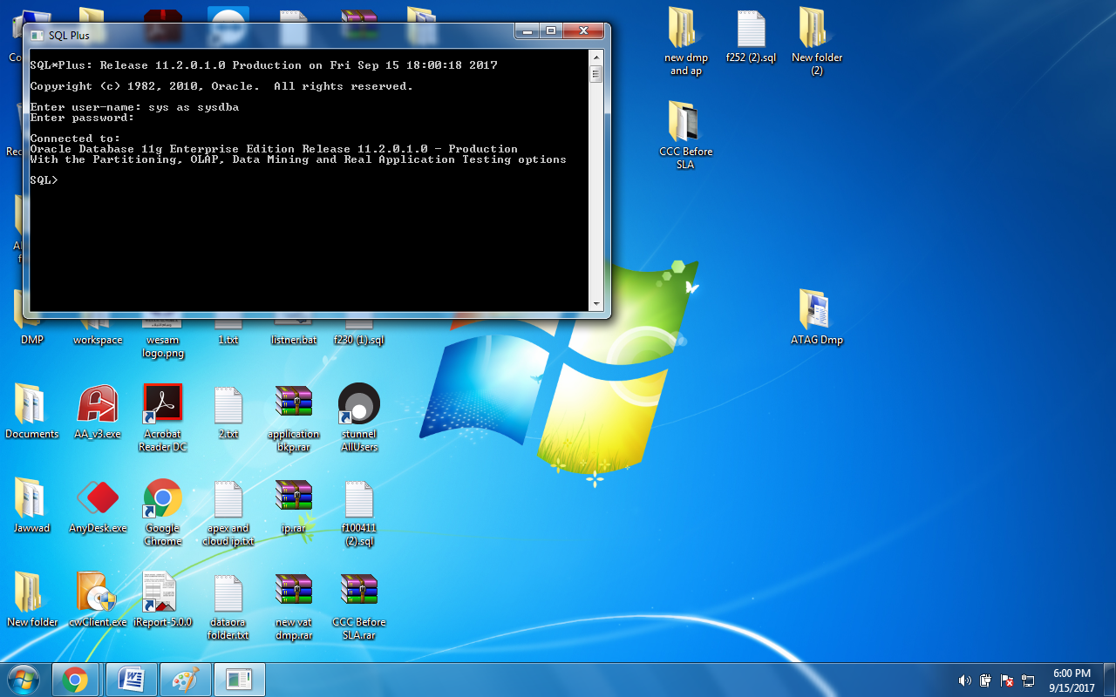

1. **Schema Creation with tablespace and DBF (Database) file.**
2. ***Create Tablespace in INDUS data folder using following command***

create tablespace WESAM datafile 'C:\app\Muzamil\oradata\INDUS\WESAM.DBF' size 500M autoextend on;

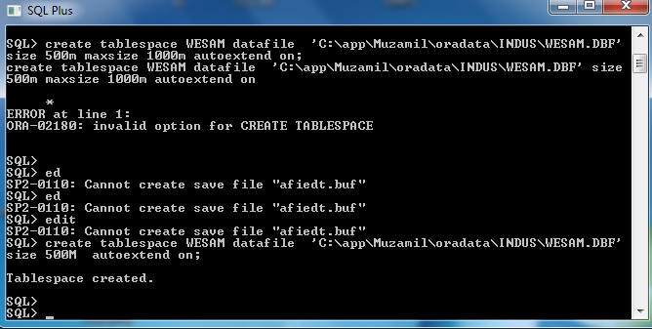

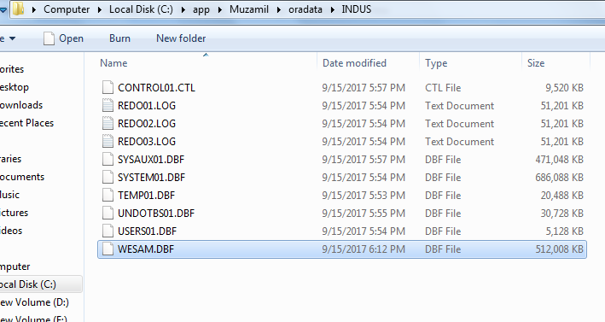

1. ***Create Schema with Reference to tablespace and DBF.***

SQL> CREATE USER CIT IDENTIFIED BY CIT

DEFAULT TABLESPACE WESAM

TEMPORARY TABLESPACE temp;

SQL> grant resource,connect,imp_full_database,exp_full_database to CIT;

Example:

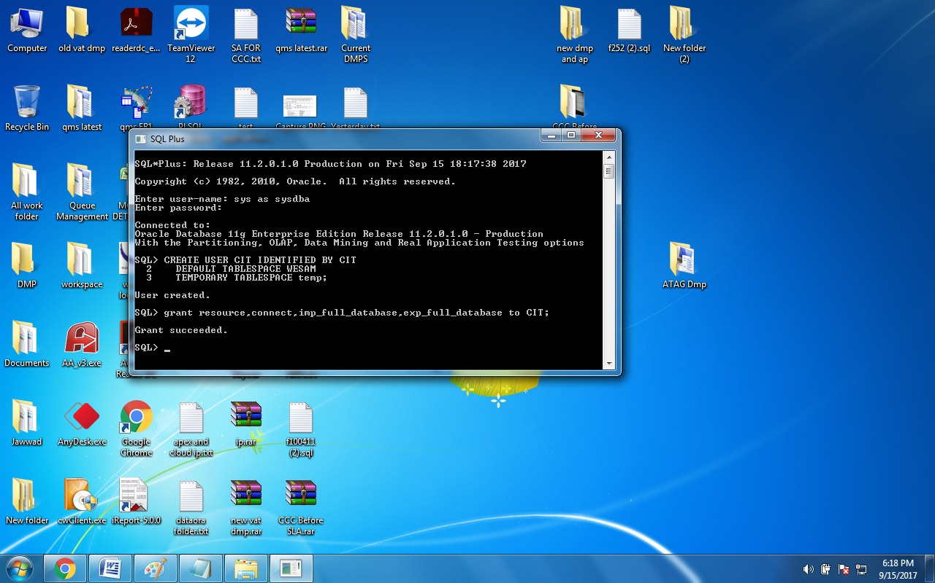

Now import DMP file using IMP/IMPDP from Exported DMP file and Run Application.

1. **RMAN Backup Configuration**

* Backup Strategy
* RMAN Configuration

**BACKUP STRATEGY**

|  |  |
| --- | --- |
| Organization | Software Channel |
| Server | INDUS-SERVER |
| Database Software | Oracle 11 Release 2 |
| Database Name | INDUS |
| Database ID (DBID) |  |
| Backup & Recovery Tool | RMAN – Recovery Manager |
| Strategy | Incremental |
| Weekly at Level-0 |
| Daily at Level-1 (Differential) |
| Backupset | Redo Log File |
| Database File |
| Control File |
| SPfile (Server Parameter File) |

Backup Schedule

|  |  |  |  |  |  |  |  |
| --- | --- | --- | --- | --- | --- | --- | --- |
|  |  | | | | | | |
| Backup  Level | 0 | 1 | 1 | 1 | 1 | 1 | 1 |
| Day | Friday | Saturday | Sunday | Monday | Tuesday | Wednesday | Thursday |

**Initial RMAN Configuration (INDUS)**

This is initial RMAN configuration for INDUS Database Server, once time we have configured if any case of disaster recovery or routine testing backup of database on other computer.

**STEP-1**

Logon to SYS user

First of all make sure your database is running ARCHIVELOG mode. If it is not running then logon to sys user and follow bellow code.

**SQL> conn sys as sysdba;**

Enter password:

Connected.

**SQL> STARTUP MOUNT EXCLUSIVE;**

ORA-01081: cannot start already-running ORACLE - shut it down first

**SQL> ALTER DATABASE ARCHIVELOG;**

ALTER DATABASE ARCHIVELOG

*

ERROR at line 1:

ORA-01126: database must be mounted in this instance and not open in any

instance

**SQL> archive log list**

Database log mode No Archive Mode

Automatic archival Disabled

Archive destination USE_DB_RECOVERY_FILE_DEST

Oldest online log sequence 1

Current log sequence 3

**SQL> shutdown immediate**

Database closed.

Database dismounted.

ORACLE instance shut down.

**SQL> startup mount;**

ORACLE instance started.

Total System Global Area 167772160 bytes

Fixed Size 1247876 bytes

Variable Size 75498876 bytes

Database Buffers 83886080 bytes

Redo Buffers 7139328 bytes

Database mounted.

**SQL> alter database archivelog;**

Database altered.

**SQL> alter database open;**

Database altered.

**SQL> archive log list**

Database log mode Archive Mode

Automatic archival Enabled

Archive destination USE_DB_RECOVERY_FILE_DEST

Oldest online log sequence 1

Next log sequence to archive 3

Current log sequence 3

SQL>

**SQL> create tablespace rec_catalog**

**datafile ‘C:\app\Muzamil\oradata\INDUS\rec_catalog.dbf’**

**size 10M autoextend on**

**extent management local uniform size 1M;**

Next we create the recovery catalog owner. The user SYS cannot be the owner of the recovery catalog.

**SQL> create user rcat identified by rcat default tablespace rec_catalog**

**quota unlimited on rec_catalog;**

User created.

**SQL> GRANT connect, resource, recovery_catalog_owner TO rcat;**

Grant succeeded.

**SQL> grant recovery_catalog_owner to rcat;**

Grant succeeded.

The role RECOVERY_CATALOG_OWNER has all of the privileges need to query and maintain the recovery catalog.

**SQL> select privilege from dba_sys_privs where grantee = 'RECOVERY_CATALOG_OWNER';**

PRIVILEGE

—————————————-

CREATE SYNONYM

CREATE CLUSTER

ALTER SESSION

CREATE DATABASE LINK

CREATE PROCEDURE

CREATE SEQUENCE

CREATE TABLE

CREATE SESSION

CREATE TYPE

CREATE VIEW

CREATE TRIGGER

**STEP-2**

Now open CMD or Command Prompt

**C:\>rman catalog=rcat/rcat@INDUS**

Recovery Manager: Release 10.2.0.1.0 - Production on Thu May 21 09:59:26 2009

Copyright (c) 1982, 2005, Oracle. All rights reserved.

connected to recovery catalog database

**RMAN> create catalog tablespace "REC_CATALOG";**

recovery catalog created

**RMAN> exit**

Recovery Manager complete.

**C:\>rman catalog=rcat/rcat@INDUS target=sys/sys@INDUS**

**RMAN> register database;**

database registered in recovery catalog

starting full resync of recovery catalog

full resync complete

**RMAN> exit**

Recovery Manager complete.

**STEP-3**

Configure the persistent parameters.

**RMAN> configure retention policy to recovery window of 7 days;**

new RMAN configuration parameters:

CONFIGURE RETENTION POLICY TO RECOVERY WINDOW OF 7 DAYS;

new RMAN configuration parameters are successfully stored

starting full resync of recovery catalog

full resync complete

**RMAN> configure default device type to disk;**

new RMAN configuration parameters:

CONFIGURE DEFAULT DEVICE TYPE TO DISK;

new RMAN configuration parameters are successfully stored

starting full resync of recovery catalog

full resync complete

**RMAN> configure controlfile autobackup on;**

new RMAN configuration parameters:

CONFIGURE CONTROLFILE AUTOBACKUP ON;

new RMAN configuration parameters are successfully stored

starting full resync of recovery catalog

full resync complete

**RMAN> configure channel device type disk format 'E:\rmanbackup\Backup%d_DB_%U_%S_%P';**

new RMAN configuration parameters:

CONFIGURE CHANNEL DEVICE TYPE DISK FORMAT 'E:\rmanbackup\Backup%d_DB_%U_%S_%P';

new RMAN configuration parameters are successfully stored

starting full resync of recovery catalog

full resync complete

**STEP-4**

Now We have created two **.rcv** files backup.rcv and backup1.rcv with two Batch file daily and weekly basis backup and add in schedule of windows 2003 server.

**WEEKLY BACKUP FILE SCRIPT**

Open notepad and write bellow code and save it bellow name with .bat extension.

**weeklybackupRMAN.bat**

echo off

rman target=sys/sys@INDUS cmdfile E:\rmanbackup\backup1.rcv

Now open notepad and write bellow rman script and save it with bellow with .rcv extension.

**backup1.rcv**

run {

backup incremental level 0 DATABASE plus ARCHIVELOG DELETE INPUT TAG WEEKLY_BACKUP;

sql "alter system archive log current";

DELETE NOPROMPT OBSOLETE;

backup spfile;

backup current controlfile;

}

**DAILY BACKUP FILE SCRIPT**

Open notepad and write bellow code and save it bellow name with .bat extension.

**dailybackupRMAN.bat**

echo off

rman catalog=rcat/rcat@INDUS target=sys/sys@INDUS cmdfile E:\rmanbackup\backup.rcv

**backup.rcv**

Now open notepad and write bellow rman script and save it with bellow with .rcv extension.

run {

backup incremental level 1 DATABASE plus ARCHIVELOG DELETE INPUT TAG DAILY_BACKUP;

sql "alter system archive log current";

DELETE NOPROMPT OBSOLETE;

backup spfile;

backup current controlfile;

}

**4.Recover & Restore Database on Finger Tips**

List of Following Errors Or Might be other disaster due to concurrently Database shutdowns. Because your Database is in archive log mode.

***Note : This method does not guarantee to restore or recover database because it depends on disaster scenarios , so first diagnose issue then try to resolve.***

1. ***ORA-011033: ORACLE initialization or shutdown in progress***
2. ***ORA-00600: internal error code, arguments***:

**Method-1**

SQL> **shutdown immediate;**

SQL> **startup mount;**

SQL> **recover database;**

SQL> **alter database open;**

SQL> **alter database open resetlogs;**

SQL> **shutdown immediate;**

SQL> **startup;**

**Method-2**

> sqlplus /nolog

SQL> connect / as sysdba

Connected.

SQL> **shutdown abort**

ORACLE Instance shut down.

SQL> **startup nomount**

ORACLE Instance started

SQL> **alter database mount;**

SQL> **alter database open;**

***NOTE: Which still gave the error: ORA-00600: internal error code, arguments***

SQL> **startup mount**

ORACLE Instance started

SQL> **recover database**

Media recovery complete

SQL> **alter database open;**

Database altered

**METHOD-3**

SQL> **shutdown abort**

ORACLE instance shut down.

SQL> **startup mount**

ORACLE instance started.

Total System Global Area 1904054272 bytes

Fixed Size 2404024 bytes

Variable Size 570425672 bytes

Database Buffers 1325400064 bytes

Redo Buffers 5824512 bytes

Database mounted.

SQL> **recover database**

Media recovery complete.

SQL> **alter database open;**

alter database open

*

ERROR at line 1:

***ORA-00600: internal error code, arguments:***

SQL> **shutdown abort**

ORACLE instance shut down.

SQL>

SQL> **startup mount**

ORACLE instance started.

Total System Global Area 1904054272 bytes

Fixed Size 2404024 bytes

Variable Size 570425672 bytes

Database Buffers 1325400064 bytes

Redo Buffers 5824512 bytes

Database mounted.

SQL**> shutdown abort**

ORACLE instance shut down.

SQL> **startup mount**

ORACLE instance started.

Total System Global Area 1904054272 bytes

Fixed Size 2404024 bytes

Variable Size 570425672 bytes

Database Buffers 1325400064 bytes

Redo Buffers 5824512 bytes

Database mounted.

SQL> **recover database using backup controlfile until cancel;**

ORA-00279: change 4234808 generated at 01/21/2014 18:31:05 needed for thread 1

ORA-00289: suggestion :

C:\APP\USER\FAST_RECOVERY_AREA\ORACLEDB\ARCHIVELOG\2014_01_22\O1_MF_1_108_%U_.AR

ORA-00280: change 4234808 for thread 1 is in sequence #108

Specify log: {<RET>=suggested | filename | AUTO | CANCEL} ***PRESS ENTER***

C:\APP\USER\ORADATA\ORACLEDB\REDO03.LOG

Log applied.

Media recovery complete.

SQL> **alter database open resetlogs;**

Database altered.

**NOW SHUTDOWN AND START DATABASE**